Name_____________________________________________ Date_____________________ Period______
Chapter 22.1, the Economy of Sub Saharan Africa Today
Direction: Complete each task. Some correspond to the textbook (page numbers provided) and others are free-standing activities. Answers need to be thoughtful with grade level analyzing.
- Etch-A-Sketch Vocabulary, page 557

Define/Give Examples (Specific to that region) | Draw a picture to explain the definition and/or example (Specific to that region)
Subsistence Farming

Shifting Cultivation

Sedentary Farming

Commercial Farming

Cash Crop

Page 557 Agricultural Workforce (Selected Countries)
- (Skill Practice: Analyzing Maps) Compare the figures in the bar graph to the vegetation regions for the countries shown on page 502 of the Regional Atlas. What seems surprising about the number of agricultural workers in a country when one looks at its vegetation?

- Which country has the greatest percentage of its workforce employed in Agriculture?

Page 558 Zimbabwe Conflict Over land

- (Cause and Effect)
  - Cause#1: ______________________________________________________________
  - Effect#1: The solution was to redistribute land to all farmers

  - Cause#2: Land was redistributed to all farmers
  - Effect#2:______________________________________________________________

Page 559 Mining Resources

- (Expository Writing) Why has South Africa’s gold not helped the black majority in the country? Write a paragraph explaining the point of view from a black South African.

____Roads of Sub-Saharan Africa____
Lack of adequate infrastructure in sub-Saharan Africa is the primary problem of distribution of food. As statistics show, over half of the rural roads in Sub-Saharan Africa are in a very poor condition and repairs are needed immediately. As a response to this problem, the solution will be primarily focused on improving existing major corridors and constructing roads in places where basic infrastructure is desperately demanded.
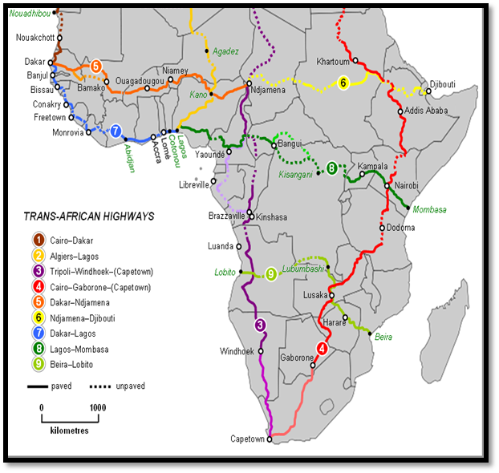
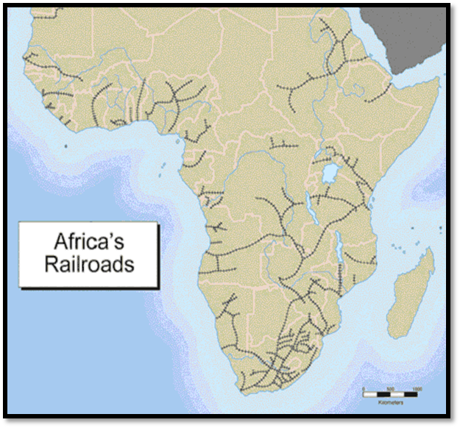
Rural Africa has only 34% road access - lands covered by roads - as compared to 90% in the rest of the world. In addition, the state of the infrastructure that does exist is generally very poor with many governments unwilling to spend the amount of money required to keep roads in basic repair. This compounds the high poverty levels and low food security levels in Sub-Saharan Africa by impairing distribution of food aid, farmer connections to market, information exchange, and trade.
http://12.000.scripts.mit.edu/mission2014/solutions/roads-in-sub-saharan-africa

- Using background knowledge and what you know about Africa, what are some other problems (other than food distribution) that poor road/railway systems might cause in Africa?

