Name_____________________________________________ Date_______________ Period______
5 Themes of Geography Interactive Note-Making

Lesson Objective:
- To be able to list and define the five themes of geography.
- To be able to apply the 5 themes of geography to the Yorkville area

THE FIVE THEMES OF GEOGRAPHY

- Location
- Place
- Human-Environment Interaction
- Movement
- Regions

LOCATION
Where are we?
- Absolute Location
  - A latitude and longitude (global location) or a street address (local location).
- Paris France is 48º North Latitude and 2º East Longitude. The White House is located at 1600 Pennsylvania Ave.

Practical Ways to Use Absolute Location? Why to impress your family and friends with your knowledge of the absolute location of your FAVORITE baseball teams! (pg. RA 18-19, front of your book)
Latitude | Longitude | City | State | Baseball Team Name
41°N | 74°W
40°N | 105°W
34°N | 84°W
29°N | 96°W
39°N | 84°W
38°N | 123°W
42°N | 88°W
47°N | 122°W
39°N | 90°W
42°N | 82°W
43°N | 71°W
34°N | 117°W
39°N | 76°W
Word Bank on next page….
Word Bank:
Orioles
Indians
Cardinals
Dodgers
Giants
Rockies
Cubs
Yankees
Astros
Braves
Mariners
Red Sox

Reds

- Relative Location
  - Described by landmarks, time, direction or distance. From one place to another.
      - Go 1 mile west on Main Street and turn left for 1 block.
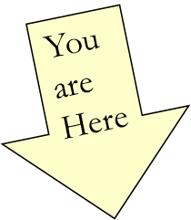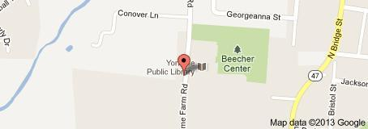

Why might sailors be interested in knowing absolute location?

PLACE
What is it like there, what kind of place is it?
- Human Characteristics
    - What are the main languages, customs, and beliefs.
    - How many people live, work, and visit a place.

- Physical Characteristics
    - Naturally occurring Landforms (mountains, rivers, etc.), climate, vegetation, wildlife, soil, etc.

What are the physical and cultural features of your neighborhood?

HUMAN-ENVIRONMENT INTERACTION
- How do humans and the environment affect each other?
  - We depend on it.
    - People depend on Lake Michigan (and other sources) for water and transportation
  - We modify it.
    - People modify our environment by
heating and cooling buildings for comfort.
  - We adapt to it or change it.
    - We adapt to the environment by wearing
clothing suitable for summer (shorts) and
winter (coats), rain and shine. We cut down forests to build houses.
- What steps would you take to adapt to your environment if you lived in Alaska?

- Florida?

MOVEMENT
- How are people, goods, ideas moved from place to place?
  - Human Movement
    - Trucks, Trains, Planes
  - Information Movement
    - Phones, computer (email), mail
  - Idea Movement
    - How do fads move from place to place?
TV, Radio, Magazines
- How might ideas have moved from one place to another hundreds of years ago?

- Today?

REGIONS
- How are Regions similar to and different from other places?
  - Formal Regions
    - Regions defined by governmental or administrative boundaries (States, Countries, Cities)
    - Regions defined by similar characteristics (Corn Belt, Rocky Mountain region, Chinatown).
  - Functional Regions
    - Regions defined by a central place and its surroundings. (Chicagoland, or other metropolitan regions).
  - Perceptual Regions
    - Regions defined by popular feelings (The Heartland- an area where traditional values are believed to be predominate)
  - Vernacular Regions (Not in your book)
    - Regions defined by peoples perception (middle east, the south, etc.)

- What do you think might be some characteristics of the United States’ Southwest region?

- If you can’t remembering what they are just ask MsR. HELP!!!
    - Ms. – Movements
    - R – Regions
    - HE – Human Environment interaction
    - L – Location
    - P - Place

Priority Pyramid:

Rank the following list from greatest importance to least importance when investigating the geography of a region: location, place, human-environment interaction, movement, and region. Be prepared to back up your reasoning!

Summarize the 3 most important ideas from this lecture:

1.

2.

3.

